**3D puzzle**

1. **Description of the design goal**

My 3D puzzle design was inspired by the following design, which could be accessed by the link: <https://www.thingiverse.com/thing:1186202>. Below is how it is supposed to look like.

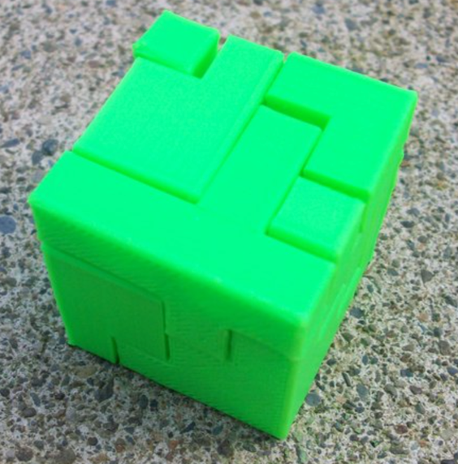 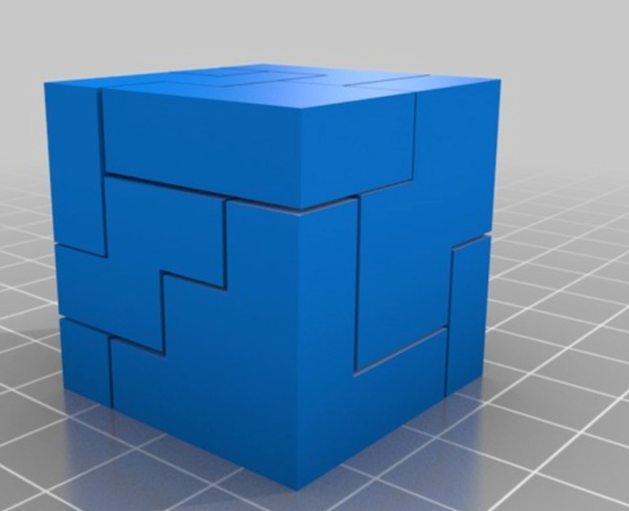

This is a 9-piece 3D puzzle cube. Each piece is different. Following is several views that illustrate the model design.

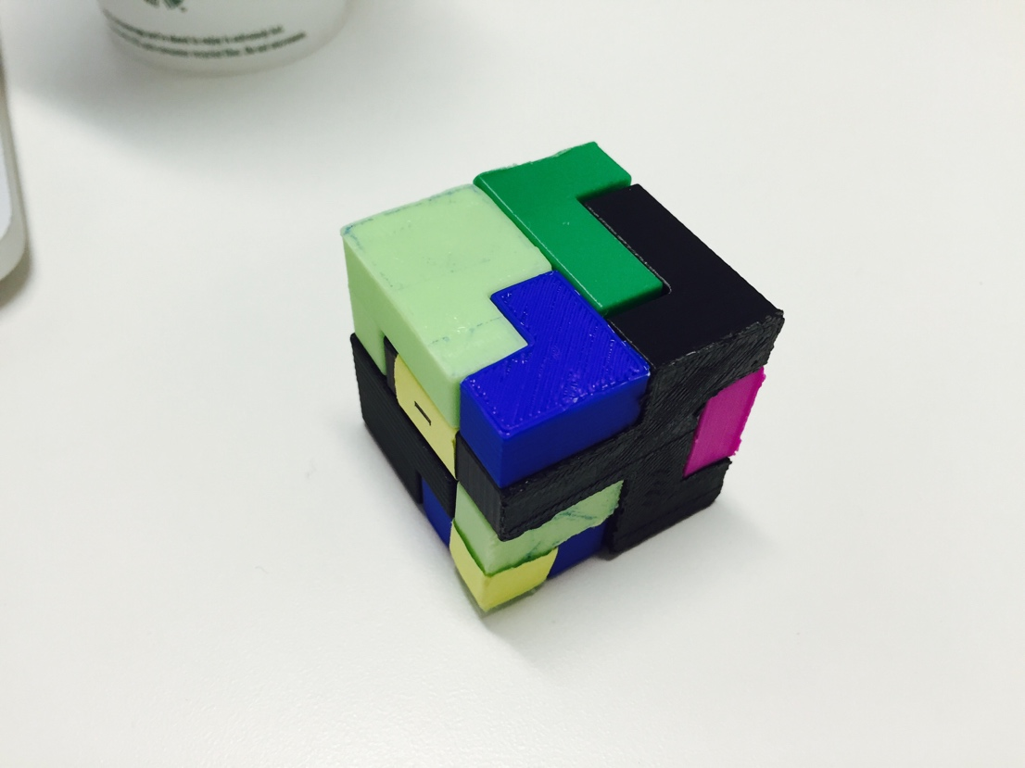 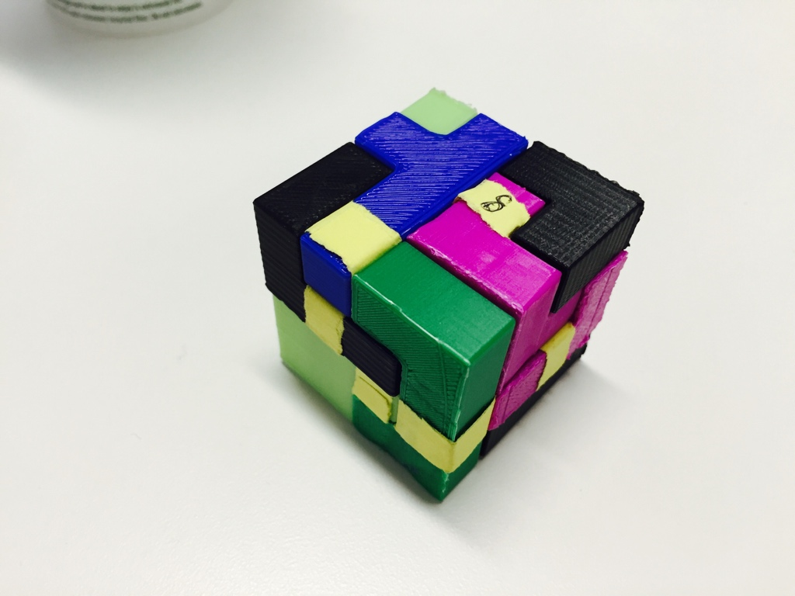

1. **3D models**

As previous mentioned, the design consisted of nine different pieces. All the parts are available in the folder. Here is an overview of each solid. And I marked each piece with a number associated to that part in .stl and .ipt files.

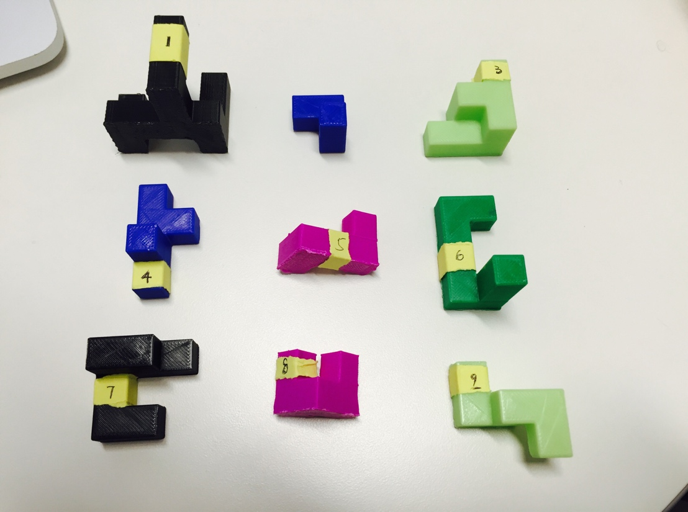

1. **Demo**

Video can be accessed through <https://youtu.be/eoHhFVPY9Gg>